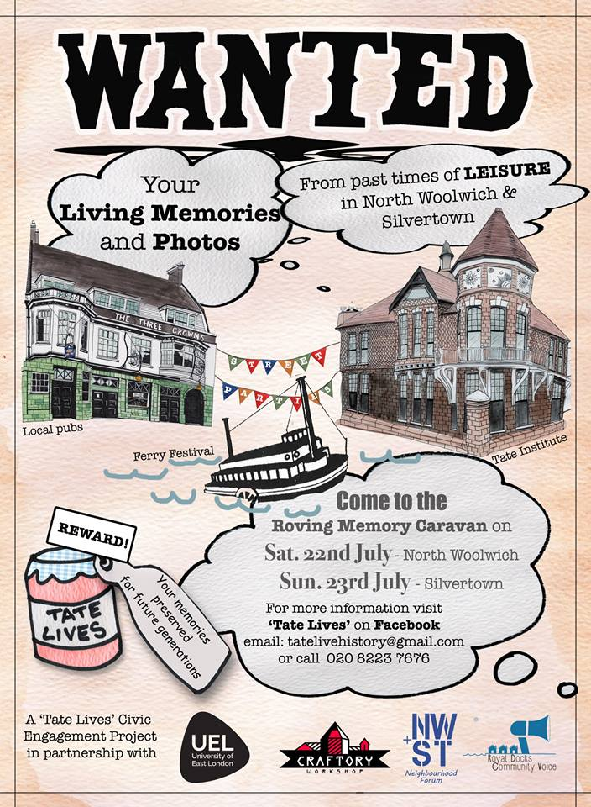
Tate Lives: Salvaging the Oral History of the Tate Institute Project
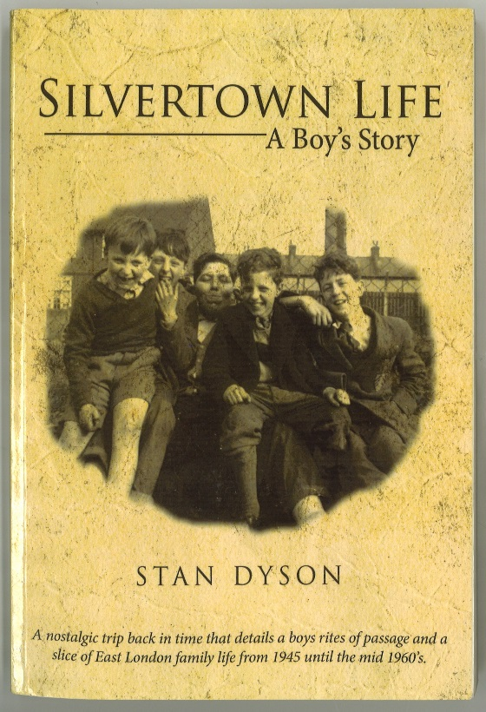
North Woolwich and Silvertown are located south of the Royal Albert Docks and London City Airport, and the Tate and Lyle Sugar Refinery is clearly visible from our UEL Docklands Campus. This area of East London has experienced a mixed cultural history over the past century. Issues of decline, regeneration and immigration, combined with the policies and interventions of local government in the region, have subsequently contributed to growing community isolation and a loss of community spirit, contributing to a decline of sense of community and neighbourhood in these areas. This paper argues that our participatory approach of the Tate Lives project, developed by incorporating a bottom up oral history methodology, has enabled positive community engagement and interaction to help facilitate a community (re-) connection with their collective memory of both the Tate Institute and more broadly a shared sense of history and community within the local area. Through our work, we created a space for the local community who felt a sense of ownership and engagement with the project, as the project was intended to give a voice back to the community and to genuinely document their own narratives, testimonies and memories to which they felt have been overlooked for a long time.
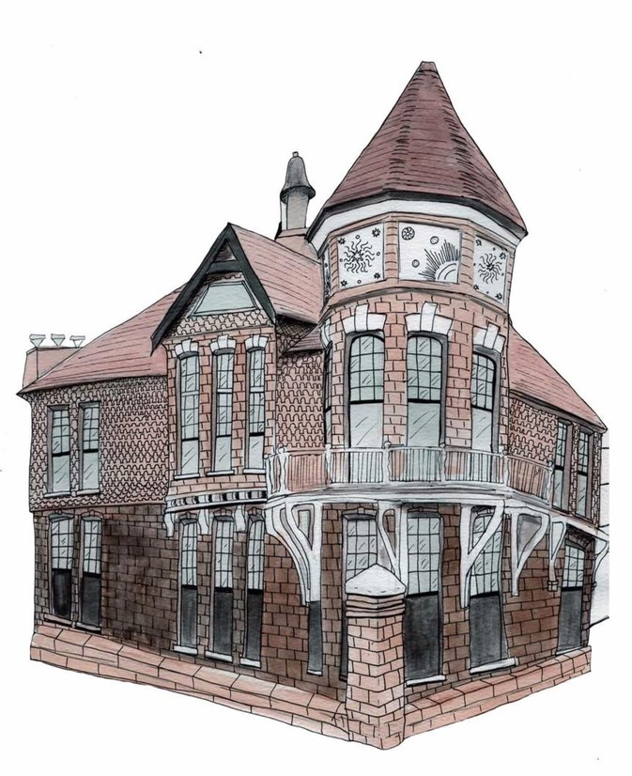
The positive experiences of working with a participatory oral history project enabled incorporation of art and travel for (re)connecting communities at a time of isolation and separation. This is concluded by placing this project in the wider policies associated with civic engagement, drawing on current and previous projects developed around the Refugee Council Archive, at UEL.
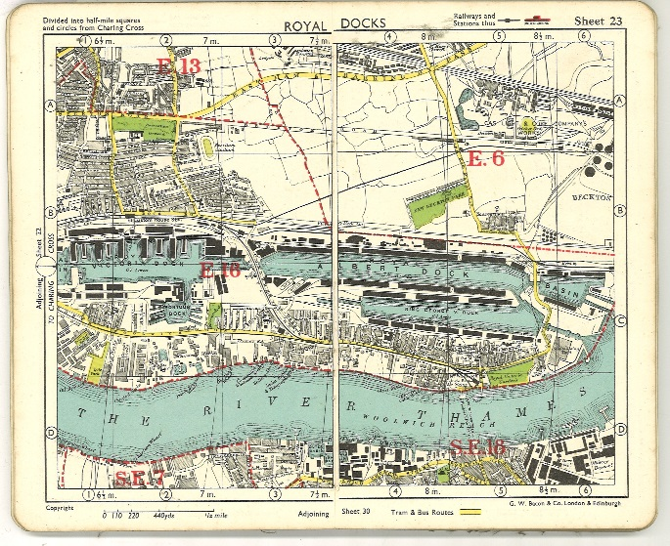
The Tate Institute was established by Sir Henry Tate in 1887 as a secular social venue for Silvertown and, in particular, for the workers at his sugar factory at a cost of £5,000, with a subsequent donation of £1,500 to renovate the institute in 1904, followed by a further £1,200 to endow it two years later. The Institute included an 800-seat hall, billiard room, reading room and nine bathrooms. It soon became an important meeting venue for the local community hosting lectures, popular musical entertainment, celebrations and even political meetings. The Institute also had sports teams that played at the Tate and Lyle sports ground.
In 1933 the Tate Institute closed and from 1938-61 housed the Silvertown library. It then became a community-based social club with a bar, stage and dance floor and the billiard room was put back into use upstairs. In 2002, the Tate Institute building was sold to the London Borough of Newham and for some years had been left unused.
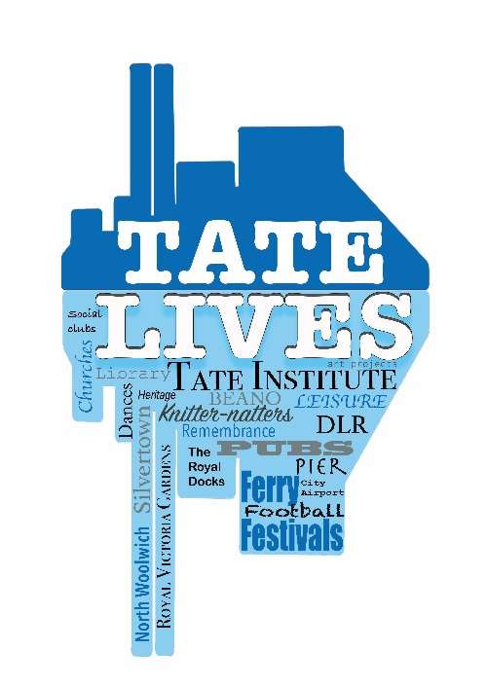
In 2016 the Institute was occupied by the Craftory Workshop, a community arts-based project. With the assistance of sympathetic local councilors, Craftory worked to bring life back into the abandoned Tate Institute and transform it into an arts and craft centre for the local community. Craftory had the aim of “bringing back life into the abandoned Tate Institute and transform it in a new free Venue for the Community.”
One of the core outputs of this project was the creation of a community-focused exhibition which would initially be showcased over 1-2 community event days to be held in Silvertown and North Woolwich during the summer of 2017. Our aim was to bring the local communities of these two areas together and to both learn about and share the history of the Institute. Prior to these events, there were opportunities to work on developing an exhibition documenting the History of the Tate Institute to be showcased at the summer events. We envisaged these events to be held outside in the community, with the floorplan of the Institute being recreated in order to encourage storytelling and community recollections of people’s time in the Institute.
Our Tate Lives project outputs included:
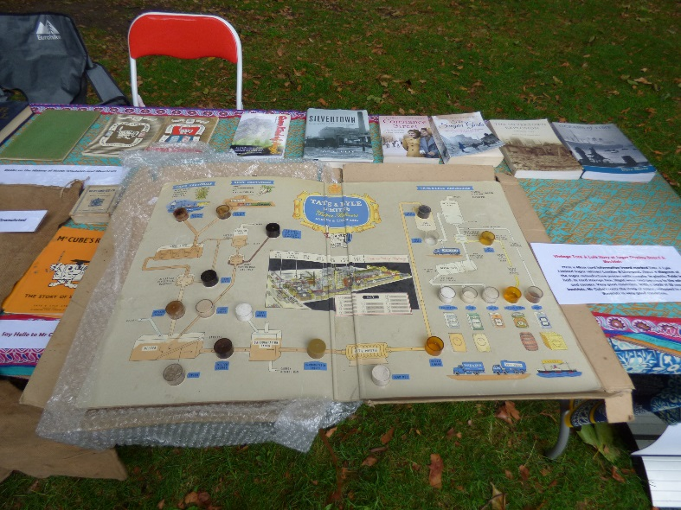
- A travelling exhibition on the history of the Tate Institute; the North Woolwich Ferry Festival; Lost Local Pubs and Community History. The exhibition has been on tour at two public events in July 2017, followed by a stay at the local Royal British Legion in Silvertown. It has also been in North Woolwich Public Library as part of the Newham Heritage Week.
- The creation of a “Tate Lives” video documentary recording the project made available on Youtube.
- The collection of several filmed oral history recordings documenting the local community history. These recordings were documented and preserved within the UEL Archives.
- The creation of a “Tate Lives” archive is preserved within the UEL Archives, incorporating outputs from the project including Tate and Lyle memorabilia; books; photographs; digital research resources; and exhibition materials.
- An active community page on Facebook providing the opportunity for continued community interaction and the sharing of memories and local history on both the Tate Institute and the local community.

