Policy Owner: Director of People & Culture, HR Services
This Policy is reviewed every two years by Education & Experience Committee and approved by University Executive Board
Version | Effective  From | Amendments | Equality  Analysis | Stakeholder  Consultation | Approval  Date | Author
2.0 | 01/09/2023 | Amended following feedback from Education and Experience Committee.  - Further clarification of personal and personal intimate relationships  - Prohibition of personal intimate relationships between staff and students for whom they are responsible.  - Clarification of action taken for breaches  and Academic Board  - Flowchart added | Proposed changes strengthen protections to young and disabled staff and students | Deans of Schools, Head of Complaints, Appeals and Investigations, Student Services, Student Union, HRBPs, OIE, University Secretary, Trade Unions,  Head of CELT, Chief Student Officer, Director Library & Learning Services.  Education and Experience Committee, Academic Board | 07/06/2023 | Acting Deputy Director HR
1.0 | 13/04/2022 | New Policy | 03/02/2022 | Trade Unions  Deans, Head of Complaints, Appeals and Investigations, Student Services, Student Union, OIE, University Secretary, UEB members | 13/04/2022 | Head of HR Business Partnering
Add a row each time the policy is updated (includes both minor and major updates)



Personal Relationships Policy

Table of Contents
1.0 Scope and Purpose of the Policy 3
2.0 Students under the age of 18 or Adults at Risk 3
3.0 Relationships between staff and students 4
4.0 Professional Boundaries 5
5.0 Relationships between Members of Staff 7
6.0 Compliance 8
7.0 Associated Policies 9
Appendix 1 – Definitions 10
Appendix 2 - Personal Relationships Flowchart 12

1.0 Scope and Purpose of the Policy
1.1 This policy outlines the University’s position on personal relationships between:
- members of staff and students under the age of 18 or Adults at Risk;
- between members of staff and students 18 years or older;
- between members of staff and other members of staff.
1.2 ‘Member of staff’ refers to UEL employees and workers (including External Examiners and Advisors), Honorary and Emeritus staff, and joint appointees.
1.3 ‘Student’ includes any person pursuing a course of study at the University.
1.4 This policy aims to ensure appropriate safeguards and processes are in place to prevent abuses of power and sexual misconduct; to protect staff and students from allegations of actual or perceived conflicts of interest, and to limit circumstances where a position of power may be abused.
1.5 A personal relationship is defined as:
- a family relationship; or
- a business/commercial/financial relationship; or
- a close friendship; or
- an intimate relationship (sexual and/or romantic), however brief.
1.6 A professional relationship is defined as:
- an assessing, supervising, tutoring, mentoring, teaching role; or
- a pastoral role; or
- a collaboration on a project for the university; or
- an administrative or technical support role.

2.0 Students under the age of 18 or Adults at Risk
2.1 Intimate relationships between members of staff and students under the age of 18 years, or between members of staff and students who are Adults at Risk are strictly forbidden. Such relationships are considered a safeguarding concern and would be considered gross misconduct under the University’s Disciplinary Procedure.
2.2 In addition, the Sexual Offences Act (2003) makes it a criminal offence for a person to engage in sexual activity, of any kind, with a person under the age of 18 years, where the adult is in a position of trust. The University considers all members of staff to hold a position of trust in relation to students.
2.3 All concerns about a member of staff acting inappropriately towards a student or staff member under the age of 18, or towards an Adult at Risk, must be referred to the University Safeguarding Officer, who may contact the Local Authority Designated Officer and/or the police.

3.0 Relationships between staff and students
3.1 The professional relationship between a student and a member of staff is a central part of the student’s educational experience at the University. It is vital that the staff-student relationship is one of trust, confidence and respect, and that all students benefit from equal treatment. The difference in power between a lecturer and student, or a supervisor and student, makes these relationships potentially vulnerable to exploitation.
3.2 A personal relationship between a member of staff and a student, with whom that member of staff also has a professional relationship, gives rise to an actual or apparent conflict of interest. Such a relationship creates, or may reasonably be perceived to create, a risk of favouritism or abuse of authority. It also undermines the relationship of trust and confidence which is intrinsic to interactions between staff and students.
3.3 Staff, regardless of role, are in a position of trust and are under a duty to act with integrity and not to place themselves in a position of actual or apparent conflict. Therefore, excepting family relationships, personal relationships with students are strongly discouraged.
3.4 In addition, the University prohibits personal intimate relationships between staff and students where the staff member has responsibility for assessing, supervising, tutoring, mentoring, teaching, or has a pastoral responsibility for that student.
3.5 Should a personal relationship already exist, when the member of staff or student enters the University; or develops while the student is registered at the University, it is the responsibility of the member of staff to disclose the relationship immediately.
3.5 Members of staff, who are themselves students, are required to disclose a personal relationship with another student.
3.6 In addition to any disclosure required under section 5, Relationships Between Members of Staff, members of staff are required to disclose a personal relationship with another member of staff who is also a student.
3.7 The disclosure should be made to either their Dean of School (for Academics) or Director (for Professional Services), who will liaise with HR Services to determine what actions, if any, are required to manage the potential conflict of interest. Should they prefer, members of staff may instead speak directly to their HR Business Partner or the Head of HR Business Partnering. Disclosures will be treated as sensitive and confidential, and shared on a need to know basis.
3.8 If a member of staff is unsure whether a relationship with a student should be disclosed, the member of staff should disclose it.
3.9 Any actions required to mitigate conflicts of interest will be documented, with copies provided to the relevant parties and placed on the staff member’s personal file.
3.10 Disclosures of all staff-student personal relationships will also be held on a confidential register within HR Services.

4.0 Professional Boundaries
4.1 To avoid any misinterpretation of their actions, however well-intentioned, members of staff should always consider their conduct in relation to any activities in which they are involved. To help maintain appropriate professional boundaries and to reduce the risk of allegations of inappropriate behaviour, members of staff should:
  - maintain appropriate physical and emotional distance from students, undertaking their duties in the University’s best interest, without favour towards any individual student;
  - use University communication facilities, e.g. UEL email account, telephone, software, applications and internet facilities when communicating with students. Avoid using personal communication channels, including personal social media. If there are occasions when it may be deemed practical to provide personal mobile details to contact students, e.g. on fieldwork or University activities away from campus, careful consideration should be given to using alternative channels instead, such as MS Teams or UEL email.
  - write and communicate with students in a professional and business style;
  - hold in person meetings and discussions on campus or, if this is not possible, use a public venue such as a library or café;
  - hold events at University or other public venues;
  - refer students who require support, outside of the staff member’s role, to appropriate University support services;
  - only seek personal information from a student where there is a need to know for the purpose of a University process, e.g. medical information for special consideration.
4.2 Examples of unacceptable behaviour towards students include:
- physical touching that could be construed as sexualised, e.g. touches of the shoulder; squeezes of the leg;
- comments or questions of a sexual nature; written or verbal;
- requests for sexual or other favours;
- paying undue attention to a particular student;
- giving gifts to a student, excluding prizes or incentives to which all students in the group have access;
- accepting gifts from a student, unless it is deemed to be a minor token of appreciation in accordance with UEL’s ‘Gifts and Hospitality’ policy;
- inviting a student to your home;
- visiting a student at their home or room unaccompanied, including while at conferences, on overseas trips or placements.
This is not an exhaustive list. Inappropriate behaviour will be addressed under the University Disciplinary Procedure.

5.0 Relationships between Members of Staff
5.1 The existence of a personal or consensual intimate relationship between staff members will normally be a private matter. However, where personal relationships occur in shared working environments or within the power/management structure an actual or apparent conflict of interest may arise. This applies both to pre-existing relationships and those that begin and or end whilst working together.
5.2 Members of staff must exercise care in the discharge of any decision making where a conflict of interest may arise. In particular, they must
- not solely line manage, or be line managed by, anyone with whom they have a personal relationship, as defined by this policy;
- not be involved in decision making processes relating to the conduct, employment or performance management of those with whom they have a personal relationship;
- not approve any financial payment e.g. expenses claims or allocations of funding for a person with whom they have a personal relationship;
- not be involved in any practices within the University which could be viewed as canvassing for a person with whom they have a personal relationship, e.g. through recruitment or promotion processes or via committees which influence decision making where that person or their work is discussed.
5.3 Where there is a potential conflict of interest the relationship must be declared. The disclosure should be made to either their Dean of School (for Academics) or Director (for Professional Services), who will liaise with HR Services to determine what actions, if any, are required to manage the conflict of interest. Should they prefer, members of staff may instead speak directly to their HR Business Partner or the Head of HR Business Partnering. All disclosures will be treated as sensitive and confidential, and shared on a need to know basis.
5.4 Should a personal or intimate relationship between staff members come to an end, for whatever reason, it is expected that all parties will conduct themselves in a professional manner in the workplace and not engage in personal disputes which may impact on the working environment, colleagues and/or students.

6.0 Compliance
6.1 Engaging in a prohibited relationship, as per sections 2.1 and 3.4 above, will be considered potential gross misconduct. This will be investigated under the University’s Disciplinary Procedure and may result in action up to and including dismissal without notice.
6.2 The University recognises that it may not always be apparent that an individual is an Adult at Risk. When a member of staff in an existing intimate relationship becomes aware, or has concerns, that the other party meets the definition of an Adult at Risk, they must immediately disclose this to the University Safeguarding Officer.
6.3 Failing to disclose a personal relationship as required under this policy will be considered a breach and investigated under the University’s Disciplinary Procedure. This may result in action up to and including dismissal or dismissal without notice in the case of gross misconduct.
6.4 Investigations and disciplinary action arising from breaches of the Personal Relationship Policy will continue to conclusion, even if the staff member resigns during the process.
6.5 Any allegations of harassment, victimisation or less favourable treatment of any staff member or student will be investigated as potential misconduct or gross misconduct in accordance with the University’s Disciplinary Procedure. This may result in action up to and including dismissal or dismissal without notice in the case of gross misconduct.
6.6 Complaints about inappropriate student behaviour toward staff members should be raised with the Student Conduct team and may be investigated via the Sexual Violence and Misconduct Policy or the Non-Academic Misconduct Policy as appropriate.
6.7 This policy will be reviewed at least every two years.

7.0 Associated Policies
Dignity at Work and Study Policy
Disciplinary Procedure
Gifts and Hospitality Policy
Non Academic Misconduct Policy
Safeguarding Policy and Procedure
Sexual Violence and Misconduct Policy

Appendix 1 – Definitions
1. Abuse of Power
Abuse of power is where someone uses their position of power or authority in an unacceptable manner. Abuse of power can take various forms and may include, but is not limited to, grooming, manipulation, coercion, putting pressure on others to engage in conduct they do not feel comfortable with.
2. Adult at Risk
An ‘Adult at Risk’ is someone aged 18 years or over who is, or may be, in need of community care services by reason of mental or other disability, age or illness; and who is or may be unable to take care of him or herself, or unable to protect him or herself against significant harm or exploitation.
3. Consent to an Intimate Relationship
Consent is agreeing by choice and having the freedom and capacity to make that choice. The person seeking consent should always take steps to ensure that consent is freely given, that it is informed and recognises that it can be withdrawn at any time.
2.1. Freedom to Consent
A person is free to make a choice if nothing negative would happen to them if they said no. A person is not free to choose if,
- they are being threatened with violence (by the perpetrator and/or by someone else)
- they are being threatened with humiliation
- they believe that the continuation or assessment of their studies will be at risk if they refused
- they believe that their appointment or continuation of contract or placement will be at risk if they refused
- they are being blackmailed
- there is a significant power imbalance and the party without power feels pressured to continue in the relationship against their will.
2.2 Capacity to Consent
Capacity is about whether someone is physically and/or mentally able to make a choice and to understand the consequences of that choice. A person does not have the capacity to give consent if they are asleep or unconscious; a person’s capacity may be inhibited by the influence of drugs or alcohol or the presence of a cognitive or learning difficulty, or mental health condition.
3. Grooming
Grooming can be defined as a gradual process that someone in a position of power uses to manipulate someone to do things, they may not be comfortable with, and to make them less likely to reject or report abusive behaviour. Grooming will initially start as befriending a person and making them feel special and may result in sexual abuse and/or exploitation.
4. Intimate Relationships
An intimate relationship is a consensual romantic or sexual relationship which goes beyond the bounds of a platonic or working relationship. An intimate relationship includes a one-off occurrence.
5. University Safeguarding Officer
The University has designated a University Safeguarding Officer (USO), a Deputy University Safeguarding Officer (DUSO) and Local Safeguarding Officers (LSOs) within Schools and Services. Details can be found in Appendix D of the Safeguarding Policy and Procedure

Appendix 2 - Personal Relationships Flowchart

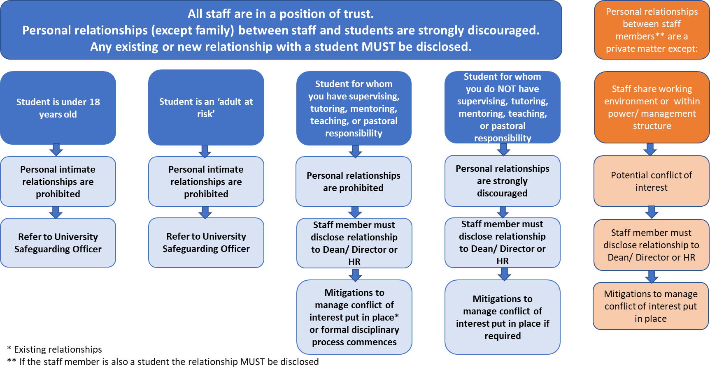

Safeguarding Adults, NHS England, https://www.england.nhs.uk/wp-content/uploads/2017/02/adult-pocket-guide.pdf

