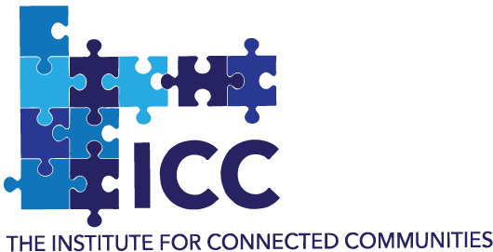

ICC SEMINAR SERIES

2024-2025

The Institute for Connected Communities (ICC) focuses on connected offline and online communities exploring contemporary issues including harms, cybercrime, safety, health, and wellbeing. In this series, we demonstrate real life projects that leveraged on multi-agency, trans-disciplinary partnerships in creating impactful initiatives.

Indicative schedule Academic Year 2024-2025

|  |  |  |  |  |
| --- | --- | --- | --- | --- |
| **Topic** | **Date** | **Presenter(s)** | **Time** | **Venue\*** |
| **1.** Promoting social inclusion through music and the creative arts | 9 October 2024, Wednesday | Jenette Fone & team | 12.00 – 1.30 PM | Online (Teams) / In-person |
| **2.** Impact investing | 11 December 2024, Wednesday | Filippo Addarii | 12.00 – 1.30 PM | Online (Teams) |
| **3.** Community development health programmes | 12 February 2025, Wednesday | Kathleen Moran & Mimi (?) | 12.00 – 1.30 PM | Online (Teams) |
| **4.** Healthcare in East London | 9 April 2025, Wednesday | Dr Sadie King, Dr Georgia & Dr Megan Clinch | 12.00 – 1.30 PM | Online (Teams) |
| **5.** Social justice | 11 June 2025, Wednesday | Caroline Tosal | 12.00 – 1.30 PM | Online (Teams) |
| **6.** TBC | 9 July 2025, Thursday | ICC PhD students | 12.00 – 1.30 PM | Online (Teams) |
| Note: The schedule is provisional and liable to change | | | | |

Join us: https://iccseminar.eventbrite.com