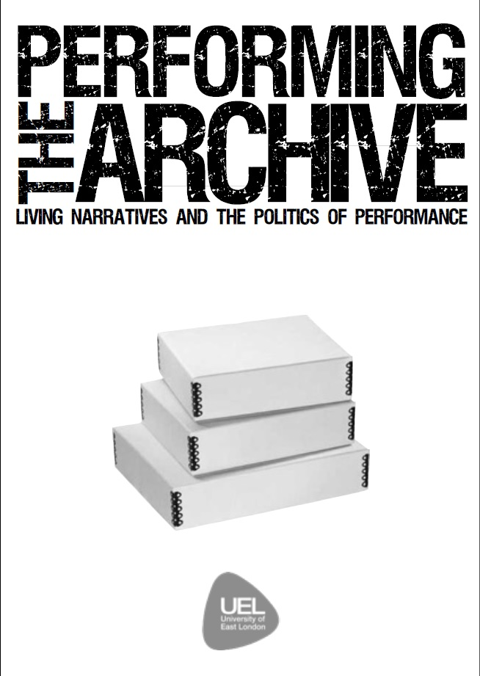

“The process of taking something static, something safely and securely put away, catalogued, labelled and put on shelves; tucked amongst other boxes, hundreds and hundreds of its brothers nestled amongst each other, hidden and sheltered, and moulding it into something theatrical, breathing, kinetic and alive —that is what our students have been faced with. A challenge that, I made clear from the start, is not an easy feat. There are no rules, and there are no answers. In a way this project has been a great chance for the students’ creativity to be let loose - the boundaries are the archives themselves, and they are so vast that they almost seem unlimited.

Getting second year students excited about an archive, was the challenge Eve and myself thought would be the first hurdle. Yet, when let loose within the multitude of boxes available at UEL I found that students immersed themselves for hours on end in the narratives that appeared throughout the archives; from the history of C.A.S.T. and the Hackney Empire (including some incredible passive-aggressive letters to and from the Arts Council at that time), to stories of refugees attempting to find asylum in East London, to details of Victorian playhouses, to intricate and detailed plans for the Olympic bid in 2012. There was life inside these archive boxes, and all we needed to do was find our own way of presenting that.

It’s been a pleasure to work with the students on this project. At times they have found themselves banging their heads against studio walls (‘How can we present an archive though?’, ‘But we want to thread three narratives together.’, ‘But how can I emulate a coffin?’), and at times, moments of creativity have shone through. It’s been an experiment in creating theatre from archival material, and I’ve found some really inspirational moments in this process. Thanks to all who have supported this project; Paul and Tom; Eve; and the students themselves.” - Tom Drayton, April 2016 www.pregnantfish,co.uk

Performing the

Archive

Library Archives

UEL



The creative process of this series of innovative performances sought to exactly investigate this complex relation, attempting to relocate the important system of knowing stored in archives to a performed knowledge of ‘doing,’ transmitted through embodied practices.

It was a process that required us to wrestle the intelligible of archival materials, of recorded and distant memories, with social constructions of bodies, stories and places in particular contexts in which the past is experienced as lived present, to be constantly unveiled, revaluated, and reinvented.

**ARCHIVE 5: ANCESTORY**

**ANOUSKA NTEZIMANA, KATARINA**

**PAULOVA, AGA ROLLNIEWICZ**

How can you create an archive for the stories that are lost? When your ancestors’ stories deserve to be collated, how can this be performed? Do your family’s stories deserve the archival process? Who will listen, and who will repeat? A mixture of stories from the UEL archives and stories of families from personal research, this performance questions the idea of archiving itself.

**ARCHIVE 2: C.A.S.T.**

**TRAM PARINEJAD, ASHLEIGH DAVIS, AMBER JENKINS, MERCEDES KEMP**

C.A.S.T. (The theatre company of Roland Muldoon before he took charge of The Hackney Empire) is fighting a losing battle against the powerful Arts Council. Money is no longer available for their community-sensitive work, yet C.A.S.T. won’t take NO for an answer. With ongoing letters back and forth between the two groups, our piece delves into this ongoing debacle at the forefront of unjust and unfair treatment that C.A.S.T. are receiving. All prose within this performance comes directly from letters between the Arts Council and C.A.S.T. in the 1980s.

“Writing is unthinkable without repression” once said Jacques Derrida and it is the act of writing that archives know only too well of how to do and how to preserve. An act nonetheless that stages its own practices of erasure and foreclosure, that reveals and is revealed by the relation of writing to ‘meaning,’ an act, finally, of past knowledge experienced as present.

THE GALLERY refers to the auctioning of an artwork by an award-winning artist. It is a participatory performance. The archival research refers to Ezogunu’s artwork which was discriminated due to his background, despite having won the Unesco award. THE STORY is based on the record of a woman called Josema, who was taught in the art of knife cutting by a lady called Agnes in the Fourteenth

Century. This was a time when Girls were also apprenticed to traders alongside boys. The performance aims to show Josema’s future, and how it was influenced by the above, THE AUDIO SPACE refers to a young girl from Iran, sharing her story of an attempt to seek refuge.

**ARCHIVE 4: UNTITLED ABDUL YOONISA**

section of verbatim transcripts from the UEL East London voices Archives about seeking refuge.

**UEL ARCHIVES:**

- REFUGEE ARCHIVES

- Refugee Council Archive at UEL, UNHCR Audio-Visual Collection, Northern Refuge Centre Sheffield, Charter 87

- BRITISH OLYMPIC ASSOCIATION

- EAST LONDON PEOPLE’S ARCHIVE (Eastside Community Heritage)

-HACKNEY EMPIRE ARCHIVE.

**LIVING NARRATIVES AND THE POLITICS OF PERFORMANCE**

**We are delighted to present a very special theatrical performance entitled Performing the Archive: Living Narratives and the Politics of Performance.**

**University of East London performing arts students, working in conjunction with Tom Drayton (Director of Pregnant Fish Theatre) and Dr. Eve Katsouraki (Senior Lecturer), are performing a series of unique theatrical pieces conceived and developed from scratch. The pieces are inspired by narratives from UEL’s library archives, including unique collections such as the archives of the Hackney Empire theatre, the Refugee Council and the British Olympic Association.**

**We aim to be London’s leading university for civic engagement, and this performance is part of our civic engagement programme, through which we invite the communities of East London and beyond to join us and share in the innovative work of our students.**

**ARCHIVE 3: THE BIRANGONA**

**OLIVIA WEEKS, BRIDGET CONTEH, MAKEDA ELLIS, ROBAB RIB, ZODWA GREGUSHA**

A performance that explores the genocide by the Pakistani army towards the Bengalis. This performance includes physical theatre and performative re-enactment of real-life stories told by the survivors and kept within the archives at U.E.L.

**ARCHIVE 1: THE GALLERY, THE STORY, THE AUDIO SPACE**

**DAINA BADIA, PRIMA NDAWUL A, ROSE HW AKAH**