Dear Colleagues,

Welcome back to the new academic year 2021/2022! I hope you enjoyed a restful summer break and look forward to engaging with you on our transformational agenda for the year ahead.

Thank you to Anulika and John who managed to join us for some of our marathon of graduation ceremonies in September – the 17 events over 7 days based in a pavilion at ABP and with Docklands campus celebrations were a great success, with the joy and pride of our graduates and their families hugely inspiring to engage with.

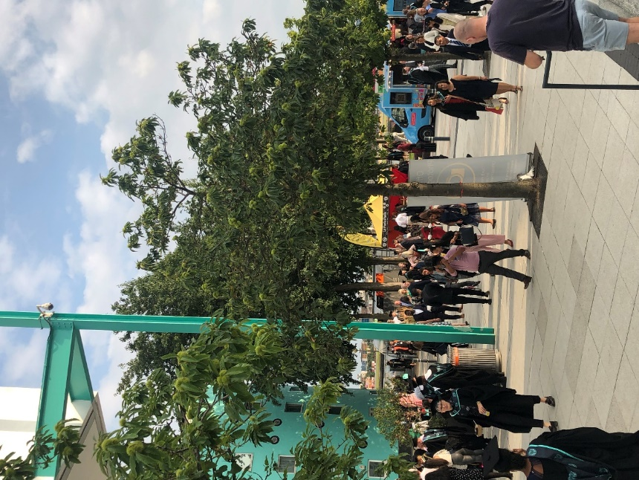 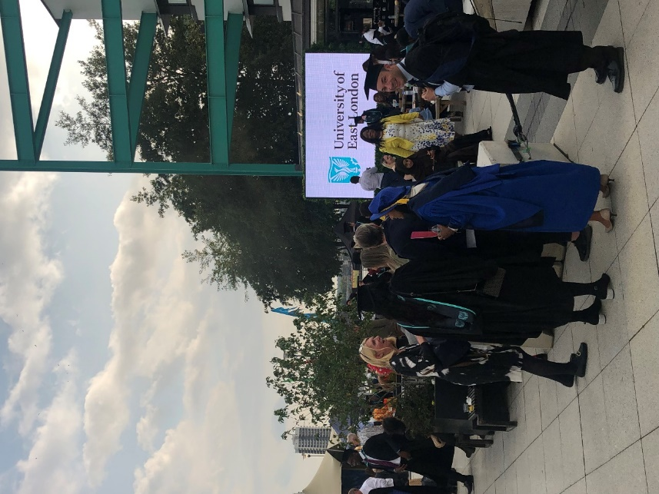



Welcome also to our new governors the Reverend Trevor Critchlow who joins us as an independent governor and to our student governors Lavanya Rajendran and Irfana Kottikulam-Aboobacker I look forward to working with you. Colleagues will be aware that we have commenced our search for a new Chair of Governors to succeed Anulika in July 2022. For those who wish to share the advert via their social networks, please find the LinkedIn link [here](https://www.linkedin.com/feed/update/urn:li:activity:6841408977910145024?updateEntityUrn=urn%3Ali%3Afs_feedUpdate%3A%28V2%2Curn%3Ali%3Aactivity%3A6841408977910145024%29).

Our 1st week of term and the end of September finished positively, with a wonderful firework celebration evening at Stratford Campus; with achieving 3rd place in the National Recruiter Awards for Best Employability Strategy (out of 10 short-listed – we’re already writing next year’s application!); and, for winning a £360k grant from the Office for Students to increase the diversity of the BAME talent pipeline in postgraduate research.



*Please click here to see a short video of the ‘welcome back to campus’ celebration*: 

Please find below the September Governors’ monthly update.

1. **2020/2021 Pre-Audit Financial Statements**

The audited 2020/2021 Financial Report & Accounts will be brought to the Board of Governors in November following review by A&RC and F&RC. The headline pre-audited numbers are:

* Operational surplus at £19.9m
* Cash balance at £66.0m

The increased surplus (following the last report) comes from higher income and lower pay costs in the last few months of the year than forecast and not needing to utilise the non-continuation pandemic reserve. This additional surplus together with increased student fee deposits for the new academic year and payment timing issues on the capital programme have led to an outstanding cash balance at year-end.

1. **October 2021 New Start Entrants (NSE) Student Recruitment**

The Autumn entry point does not close enrolment until the 3rd week of October with UEL and the majority of post-1992 universities historically experiencing a long tail of late recruitment so forecasting remains volatile. The Main recruitment cycle (to May 2021) and Clearing 2021 (May-August 2021) performed well in the early-Clearing phase, delivering a 13% year-on-year rise in applications. We anticipate UCAS confirming our clearing effectiveness following on from last year’s number 1 London position. You will be aware of the implications of the pandemic on the national position on Level 3 qualifications this year, with [top grades reaching record highs](https://www.bbc.co.uk/news/education-58086908) and subsequently record levels of students accepted into 1st choice and higher tariff institutions. Increased deferrals and the smaller national clearing pool have impacted on all mid- and lower-tariff institutions.

As stated, the enrolment process will not conclude until mid-October and there remains some way to go to get the full picture but the forecast recruitment level indicates that we may slightly undershoot the Autumn entry targets with a potential overall forecast impact of **£0.5m reduction in income**.

This does not change the budgeted surplus target for the year as we would absorb this into our financial planning process and we still have two further entry points to make gains. Even if the outcome of Autumn entry/Semester A does result in a reduction in income against target the University would still achieve an 13.8% growth in income year on year (one of, if not the highest growth, in the sector).

We currently stand at 3646 UGT Home Firm Accepts (3325 Unconditional Firm Accepts) against the stretched new student enrolment target of 3654 (and we continue to receive approximately 40 Unconditional Firm Accepts per day as we lead up to the final weeks of deadlines.). For the international market, we have issued a total of 1430 CAS (visa pre-requisites) into the market forecasting that we are close to achieving the stretched enrolment target for October 2021 entry of 1493.

1. **Return to Campus**

On 1st September, following intense preparation and communication over the summer, we moved to Covid-19 [Tier 0 operational status,](https://www.uel.ac.uk/about/tiers-operation) maintaining a Covid-secure campus and advancing our risk assessments and mitigations as and when circumstances evolve. Over the period of the pandemic[, our Covid-secure campuses,](https://uelac.sharepoint.com/sites/ExternalRelations/SitePages/Covid-19%20information%20hub.aspx) our [tiers of operation](https://uelac.sharepoint.com/sites/ExternalRelations/SitePages/Tiers-of-restriction-%E2%80%93-how-the-University-will-respond-to-changes-in-Covid-19-infection-rates.aspx) and our [dual delivery educational model](https://uelac.sharepoint.com/sites/home/SitePages/Dual-Delivery-2.0.aspx) has resulted, unequivocally, in a safe working and learning environment (with extremely [low Covid-19 on-campus transmission rates,](https://www.uel.ac.uk/about/return-campus/covid-19-active-case-statistics) significantly lower than both the Newham borough and transmission levels nationally) supported by on-campus testing and vaccination and with timely and relevant information about Covid-19 changes and responses. A recently published KPMG internal audit has commended both the University’s workforce and student health and well-being provision with a positive rating driven by the robust processes put in place in response to the pandemic and the progression from this to a Covid-specific suite of mitigations. KPMG also identified good practice with the centrally-issued University-wide communications throughout the pandemic and the planning and preparatory work around the return to campus for both staff and students.

Our community is expected to commit to the [UEL Community Wellness Pledge](https://www.uel.ac.uk/about/return-campus/covid-19-community-wellness-pledge) and keep up-to-date with the active role we all play in our Covid-Secure Campus requirements. Wellness Pledge Desks across our campuses reinforce our expectations for all staff, students, and visitors. This pledge is focused on supporting key actions to be followed to keep everyone safe. This includes:

* Receiving two Covid-19 vaccinations in the community or on campus, if eligible;
* Undertaking Covid-19 asymptomatic tests twice weekly at home, on campus or at a community testing site;
* Checking-in to Campus via the [University Safezone App](https://www.safezoneapp.com/) (and the [NHS Covid-19 App](https://gov.wales/nhs-covid-19-app)); and,
* Wearing a face mask when indoors on-campus in enclosed and crowded spaces unless you have a health or disability exemption.

In collaboration with Newham Public Health, we have [on-campus vaccination clinics](https://uelac.sharepoint.com/sites/ExternalRelations/SitePages/On-campus%20vaccination%20clinics.aspx) at Stratford and Docklands campuses offering, those eligible, doses of the Pfizer vaccine. [Testing facilities](https://uelac.sharepoint.com/sites/trackmyfuture/SitePages/Testing-Centre.aspx) are also available at Stratford and Docklands campuses and offer quick-turnaround asymptomatic tests and free home test kit collection. Stickers are available at our Wellness Pledge Desks and testing centres to demonstrate that a member of the community has confirmation of a negative test within the last 48hours. It is a legal requirement for staff to inform their line managers if they have confirmed Covid-19 and are thus self-isolating. In these circumstances, staff also complete the [UEL Health Update Notifier](https://uelac.sharepoint.com/sites/ExternalRelations/SitePages/Daily-and-initial-Health-check.aspx).

At the entrances of teaching spaces (where applicable), clear signage reminds students that a face mask is recommended to be worn in these spaces. Staff are also encouraged to wear a clear face mask or visor when teaching to ensure an inclusive learning experience – these are available for collection at reception desks and School Offices. CO2 monitoring audits are being deployed through the term to monitor mechanical and natural ventilation in place in teaching rooms (and thus potential atmospheric viral load). The Infection Response Group (IRG) continues to monitor infection rates amongst the student and staff community, in partnership with Newham Public Health. Active case data is reviewed on a daily basis, enabling swift and proactive responses to any confirmed cases of on-campus transmission which, to date, have remained low to nil throughout the 19 months of the pandemic.

September has also delivered our [2nd University Development Week](https://uelac.sharepoint.com/sites/hr/SitePages/Development-Week.aspx), a two-day Campus Trial-run programme, International Arrivals, Residential Arrivals, Welcome & Induction Week, and ofcourse Week 1 of academic term starting on Monday 27th September. There is a genuine feeling of excitement and joy in coming back together physically on-campus and it is wonderful to see our campus vibrancy starting to blossom. There remains much to do and a necessary period of transition, reflection and support as we all adjust to the exceptional period of the last 19 months. We are not yet out of the pandemic and there continues to be multiple impacts that both management and the wider University community continue to deal with.

**4.0 Education & Experience**

A selection of recent progress in our Schools include:

* The School of ACE has established a new Aeronautical Engineering workshop in Knowledge Dock and a flight simulator "Merlin’s proven MP521" has been housed in this area for training. The flight simulator is a new state-of-the-art engineering facility with hands-on specialist learning that was installed on site at the end of August. This simulator artificially re-creates aircraft flight and the environment in which it flies for pilot training, the design and development of aircraft, and for research into aircraft characteristics and control handling qualities.
* Applications have been submitted to the Institute for Apprenticeships & Technical Education for 4 High Technical Qualifications in their Cycle 2 call. These 4 courses are designed at level 3, Level 4 and level 5 (and aligns with the government’s policy changes) in Construction, Cyber Security, Business Analyst and Data Science & Artificial Intelligence.
* The Institute for Apprenticeships and Technical Education approved HTQs will receive a quality mark from the Dept for Education, and the DfE will begin a marketing campaign promoting HTQs to employers and learners beginning this autumn. The School of ACE is currently working with AEPO and all other 5 schools on the OfS call to apply for funded short courses as part of the Government’s funding proposal for lifelong learning, aiming to submit an application by the Deadline of 28 September, and ultimately setting up an UEL wide Institute for Lifelong Learning and Continuing Professional development. The School is responding to a Siemens call for innovative ideas to reduce carbon emissions.
* Architectural and Physical Design have been successful in applying for grant funding (£30k) to carry out an innovation international research collaboration in Russia. The project will focus on existing buildings in-use energy performance and involve a collaboration with Moscow State University of Construction. The funding secured allows for a tutor and 3/4 students to visit Moscow and Sochi (home of the 2014 Olympic Games) to assess and visit buildings that have already been BREAM validated and assess their ongoing performance. The research will culminate in a dual delivered conference held at the University to discuss the finding of the report.
* On 7th September the School of Educom started teaching on the Postgraduate Initial Teacher Education Courses (PGCE and there were over 550 in the group covering Primary, Secondary, and Post compulsory phases of teacher training. The School has partnered with CAPITA to deliver the new Early Career Framework for newly qualified teachers and has also successfully tendered for a £400,000 DfE award to expand their pre-course subject knowledge enhancement courses (leading to PGCE for applicants without Degree level qualifications in their specialist area.
* This Year sees the first students enrolled to the BA (Hons) Montessori Pedagogy Top Up Degree. Although a small cohort, these students who completed the Foundation Degree with our Partner MMI, will be first Degree Level Graduates with a specialist Montessori qualification in the UK. Two new apprenticeship routes have been approved through Growth and Diversification board, these are: Academic Professional Teaching and Academic Professional – Research.
* HSB has engaged in good conversations across London about midwifery with commitment from the NEL partnership to support a midwifery course at UEL and HEE have given UEL the green light for delivery of the MSc Physician Associate course and will support grants for students and tariff for placements. HSB has successfully submitted a £3m bid to OFS for further developments in the hospital and primary care hub and have 4 new NHS partners. Plans are ongoing for the CE building as a hospital and primary care hub. Finally, it was excellent to graduate our first nursing students and first Chemistry students in September.
* The School of Psychology third pop-pop museum event runs between the 17th September and 1st October. As well of its traditional role of illustrating the history of Psychology at UEL, the museum this year focuses on two themes: the central role that UEL played in the development of Counselling as a discipline in the UK; and, the way in which the technology available to psychologists has evolved over the history of psychology teaching at UEL
* The first phase of the Psychology TEMPL project has now been delivered on-time and on-budget, and the first students have taken advantage of the new facilities:  Work now starts on the second phase of the TEMPL project, which involves integrating the space into the School’s normal teaching schedule and developing new training programmes to introduce students to the state-of-the-art eye tracking facilities that TEMPL has available. Colleagues are also working to submit a cross-university bid to the OfS Short Course Competition, deadline end of September, to develop a portfolio of new short courses derived from existing modules at levels 4-6. Carefully selected ‘executive-style’ courses in Psychology are being developed in parallel to this bid.
* ACI is launching a pilot to build a support network for students that promotes diversity, inclusion and equity. The Diverse Alliance will provide monthly events for staff and students alongside a moderated MS Teams site to build community and a sense of belonging. Prof. Dominic Hingorani has been awarded £30,000 by Arts Council England to support the full production of The Stopping Place. The Stopping Place is a large-scale choral project which places two sisters of Roma heritage centre stage of a diverse female chorus and drawing on music from the Romani tradition. We are delighted to be working with Newham Music to create the all-female chorus drawn from schools in Newham. <https://www.brollyproductions.com/thestoppingplace>
* BA Acting Programme Leader Juliet Knight has sourced an opportunity for our students this semester. Working with imPossible (a production company) and Matthew Dunster who have substantial funding by the Royal Docks to deliver a large-scale immersive live project. The three-day event will take place on 21st-23rd October involving about eight sites including the Millenium Mill and the company are working with local residents, bringing to life stories in and from the community.
* The School of Business and Law will be launching the new Centre of Fintech in November 2021 and there are ten companies who have agreed to sign the Memorandum of Understanding and be a formal part of the centre.
* Validation of the MBA suite in Singapore with Beacon International has successfully taken place. Imminent validations include a high-profile Executive MBA with ESEM in Belgrade. Large scale MOOCs have also been approved in Egypt with Bedaya, who are working in conjunction with three Egyptian universities.

1. **Careers & Enterprise**

***5.1 To increase the overall Graduate Outcomes Survey % from the 2020 baseline recognising the focus on post-graduation engagement and support.***

Over the summer period we engaged recent graduates in a range of events online and on-campus. This included the RDSBL Alumni Bootcamp, the ACI/ACE Alumni event and a calendar of industry events and workshops. We had record numbers of alumni engage with the Career Zone during this period, with almost 1000 student and alumni event bookings in July and August alone. This was a great success during the summer period which is typically harder to engage students and alumni.

Our pilot alumni calling campaign reached 30% of our 2019/20 graduates. The team were able to gain great insight about graduate destinations and offer support to those who identified as unemployed and underemployed. Graduates were able to apply for our graduate internships and we booked a number of follow-up 1-2-1 sessions to ensure continued engagement. We are in the process of updating our 15-month post-graduation alumni strategy to include details of how we analyse the data from the calling campaign and map it onto GOS respondent data which we will start to report on weekly. We are also working with the Schools to identify free CPD, such as Business Leadership, to offer alumni who are in work in order to help them progress and keep them informed about the GOS.

***5.2 To make a step-change in employer engagement***

One of the key C&E institutional KPIs is Employer partnerships growth. It is supported by the number of PIs, which are addressed in the following sections.

5.2.1 Increasing number of active employer partners:

We currently have over 2500 employers registered with the Career Zone, of which 821 have signed up to our employer pledge. In July we ran a Hackathon event in partnership with Coca-Cola to select 8 students for exclusive one-year internship opportunities within their marketing and operations teams. The successful event provided our students with life-changing opportunities to gain paid experience in one of the world’s best marketing departments. We are currently recruiting students to take part in Diversity of Thought Programmes with ITV, MSCI and KMPG, with GTB, Decathlon and a number of other aspirational organisations in the planning stages.

Enquiries to the UEL Business Centre continue to remain high and a number of new businesses have joined the Centre since the last monthly update. Analysis of our records shows that over 60% of the directors/owners of businesses, which have joined the Business Centre since the pandemic started live within a two-mile radius of the UEL Docklands location.

5.2.2 Employer & Community Engagement

Talent Gateway Employer Partnerships Office (EPO) joined London Chamber of Commerce and Industry initiative to build a Sustainability and Green Growth/Race to Zero ‘Membership Centre of Excellence’. A focussed programme of activities will be led by members offering opportunities to network, collaborate and share good practice to support London’s development as a centre of excellence for environment, sustainability and green growth. EPO has also contributed to the development of the British Business Bank’s ‘Net Zero Intermediary Report’. The bank has spoken with 172 intermediaries across the UK to investigate the state of the ecosystem in supporting SMEs transition to net zero and is compiling the feedback into a report which will be released later this year. EPO representatives participated in the launch of the new Newham Sparks initiative, which is designed to support digital innovation within the region. Talent Gateway Head of Employer Partnerships has been invited to join the Institute for Apprenticeship’s Green Advisory Community. In this role she will liaise with employer partners to develop more green apprenticeship routes where UEL will be at the forefront potentially participating in the trailblazers of the newly developed programmes.

5.2.3 Increasing Enterprise Income

Talent Gateway EPO team have been leading on a number of bids, which are being developed and submitted throughout the month of September. Should these bids be successful, there will be a substantial amount of funds allocated for a number of projects being developed on the institution-wide enterprise priorities.

**Higher Technical Qualifications (HTQs)**

Four qualifications (Design/Construction, Digital Developer, Artificial Intelligence, Cyber Security) were submitted to the Institute for Apprenticeships and Technical Education, which is a part of the DfE. If successful, the University will be granted permission to teach these HTQs from September 2023 onwards.

**OfS Short Course Trial**

An application for £75,000 of funding to start short course provision designed to attract underrepresented groups within the higher education has been submitted. If successful, the funding would be used to develop the systems, processes, and back-office functionality for short course provision at the University.

**Mayor’s Academies**

Talent Gateway EPO team is working with RDSBL and ACE to support a bid being developed by neighbouring councils, such as Tower Hamlets, to bring increased skills training in the digital sector.

**The Good Growth Fund**

Following submission of the revised EOI in summer, we have received positive formal feedback and a recommendation from Royal Docks Enterprise Team to submit a formal bid for the Good Growth Fund funding based on our ambitious plans to transform currently underutilised Knowledge Dock Business Centre building into the Royal Docks Centre for Sustainability. This project includes both capital works as well as a new programme of delivery designed to bring graduate-level jobs and business creation to East London and will make a transformational impact within the local area and beyond.

* 1. *To make a demonstrable positive impact on student self-perceptions of employability readiness*

The Career Readiness survey has been embedded into enrolment and re-enrolment for the first time. This requires all students to identify where they are in terms of career planning when they start their journey and at the beginning of each year. This simple but powerful tool allows us to target appropriate support and proactively reach out to those that are not progressing as they should be in terms of career readiness. A full strategy is being developed to use the data impactfully to ensure an uplift in graduate outcomes. This longitudinal data will also be used to assess learning gain, the impact of employability initiatives and how various factors influence career orientation. We have also developed Career Development Plans which are personalised to suit students’ stage of career readiness, and help them to progress to the next level.

In order to expand the number of placement opportunities the team have been working in consultation with academic colleagues within the School of Architecture, Computing and Engineering and Riipen, which brings industry and academia together with real life company projects. These are embedded directly into the curriculum or completed as remote internships. We have secured 40 placements through Riipen and will be running this as a pilot in September 2021 to assess how students find this new way of gaining experiential learning. Students will be guided through the projects by academic supervisors.

##### Over the last year, 55% of our student body actively engaged with the Career Zone to access tailored employability support. This resulted in over 1000 impactful 1-2-1 career coaching appointments being delivered with nearly 20,000 event bookings made. Over 800 new employers have signed up to our Careers 1st pledge, providing support for our initiatives and regularly promoting their opportunities to our students and graduates. Organisations include The Household of TRH The Prince Of Wales And The Duchess Of Cornwall, GSK, 10000 Black Interns, Accenture and Disney. Over 4000 students engaged with our mentoring programmes.

##### We have written the 21/22 Graduate Employability Action Plan ensures that we build on the previous year’s success and outlines a new strategy for service delivery. Our Career Readiness Committee launches in October with members from Careers and Student Employment, RDSBL and the Office for Institutional Equity. This oversight group will oversee delivery of the Graduate Employability action plan and adherence to the Standard Operating Procedures, as well as monitoring KPI/PIs for the service.

*5.4 To increase direct from employer revenue (e.g. CPD, apprenticeship, sponsorships etc.)*

Apprenticeships’ income and apprentices number growth:

We have significantly overachieved our 2020-21 KPI of £1.5mln on apprenticeships funding:

* our indicative year end funding stands at £2,072,179 (final return will be done in October), while our current draw down is at: £1,931,015.61.

There has been a steady and healthy growth of apprentices’ numbers since the Apprenticeships Strategy was approved earlier this year. This term there are 4 apprenticeships programmes, which initial approval forms have been signed off as part of the Strategy implementation plan. These are:

* Senior Journalist Apprenticeship (L6) for start of delivery in January 2023;
* Senior People Professional (L7) for start of delivery in January 2022;
* Academic Professional Apprenticeship – Teacher Route for start of delivery in January 2022 and
* Academic Professional Apprenticeship – Researcher Route (same as above – for January 2022 delivery start).

As of today, we have a total of 481 apprentices continuing with us (not including the Babcock/Metropolitan Police programme), which is in line with regulatory retention rates expected from degree-level apprenticeships. Through the September recruitment we already have a total of 263 new starts this academic year, which is expected to generate a total of over £5m income through the duration of the apprenticeships’ programmes. A 100 new Associate Nursing Apprentices will be starting in November 2021; 110 Babcock apprentices started in August in September altogether this year. The Geospatial apprenticeship is becoming increasingly popular this academic year we have a total of 19 starts this academic year leading to an income of £513,000.

This is a very healthy start and we are certain we will achieve our projected numbers for this academic year following our January and May 2022 further recruitment cycles and subsequently achieve our institutional level KPI on apprenticeships income. Institute of Government and Public Policy conducted over 40 events this month, which were attended by more than 650 delegates.

*5.5 To deliver a return on investment of international partnerships, diversifying other high value international opportunities.*

Current income forecast for Academic partnerships stands at £7,861,551, which is in line with what was projected for the area through the planning round and PIs setting exercise. The same applies to the number of students with academic partners; we are expecting >13,000 students to join and continue with UEL via its partners around the world and the UK.

In July this year we have been informed of the successful outcome of our Turing bid application. UEL has been granted the full amount we bid for, i.e. £96,500 to send 40 students on international work & study placements in 2021/22.

UEL has now officially joined the QAA-TNE scheme. The Scheme applies to all UK degree-awarding bodies on a voluntary basis and operates over the academic years 2021-22 to 2025-26. It is enhancement-led, informed by robust metrics, and has the student experience at its heart. Fundamental to the new approach is collaboration between QAA and local higher education bodies to build and deepen mutual understanding, cooperation and trust. The five-year programme, one major host country/territory will normally be selected each year together with two others such as those that are emerging or developing, or those with smaller TNE numbers.

Also, this month our Academic Partnerships office has joined the Association of Commonwealth Universities (ACU) Forum and working group on developing online student mobility programmes. The working group meets on a monthly basis and progresses the development of an ACU led pilot virtual student exchange scheme.

New franchise partnerships in Singapore (LSBF and BIC) are now approved. These new partnerships consolidate UEL’s presence in Singapore, which is an important TNE market. The risks revolve around termination and teach-out, however this is minimised by the fact that both partners are reputable with collaborative experience with UK HEIs and Singapore TNE itself is a highly regulated market. In the current academic year, we are expecting LSBF-Singapore to recruit new students across four programmes, generating revenue of £125,000; BIC revenue forecast is over £57,000.

A new partnership in Serbia is going through the approval process with validation planned for late September. Serbia is a new market for UEL, seen as an important market in South Eastern Europe and a gateway for Chinese students who have the opportunity for visa free travel to Serbia. UEL is forecasting an enrolment of around 50 students in the first year with an income of around £75,000. The partnership involves the validated provision of an executive MBA.

UEL is also in the late stages of planning a partnership with Ravensbourne University London. The proposal involves a doctoral course with students enrolled at UEL and jointly supervised by academics from both institutions. It will strengthen links with a specialist local institution and support the potential for joint research and sharing of facilities.

1. **Impact & Innovation**

To coincide with COP26, we are showcasing our work on sustainability with a program of events from October to December, on campus, on-line and ‘on the road’. Our Sustainability Research Institute (SRI) was one of the first of its kind in the UK. It has established an international reputation for the application of fundamental research in ‘green infrastructure’ (ranging from peatland ecology to substrates for green roofs); resource management (including the upcycling of materials and the circular economy); and sustainable living (such as adaptive governance, community engagement and nature-based solutions). Beyond the SRI, research contributions to sustainability are found across the schools, ranging from sustainable fashion in ACI to environmental psychology in Psychology. A few highlights of our recent and forthcoming activities:

* Researchers from the SRI will have a significant presence at COP26, with preparation of multiple exhibits well underway.
  + Richard Lindsay is coordinating a physical and virtual immersive Peatland Pavilion as one of the side events during the convention. Plans for the Peatland Pavilion (developed in a partnership between UEL, UN Environment Programme, IUCN and Wetlands International) are progressing well, with many potential partners from around the world saying how impressed they are with the mock-up Virtual Pavilion (devised by our MArch students, Hussein Ali Kasim and Mohammed Patel, along with Richard Lindsay) and expressing an enthusiasm to contribute content to the final version of the Pavilion. Our current MArch students are just about to begin work on construction designs for the physical Pavilion, which will feature the iconic 'water droplet tower' devised by Hussein and Mohammed.
  + SRI staff and ACE staff and students have been supporting Michael Pinsky in getting his award-winning Pollution Pods to the event, via the Green in Docklands, then at sites across the UK on its journey from Kings Cross to Glasgow.
* Aurore Julien (SRI) has been approached about chairing a conference about transitioning to a zero carbon society, reflecting her role as research lead on the European (ERDF)-funded ‘Eastern New Energy’ project. She has also been approached about appearing on the BBC's One Show in the run up to COP26 to talk about how to make a home more carbon neutral.
* UEL PhD Excellence Student, Steph Skipp, was interviewed as part of an article on the BBC about ancient trees: [The lost generation of ancient trees - BBC Future](https://www.bbc.co.uk/future/article/20210908-the-lost-generation-of-ancient-trees). She also recently presented her research at the international IALE conference: [The Landscape Ecology of Forests, Woodlands and Trees | ialeUK - International Association for Landscape Ecology](https://iale.uk/conference2021)
* Stuart Connop (SRI) co-authored a new European Commission publication on Evaluating Nature-based Solutions that has now been published: [Evaluating the impact of Nature-based Solutions: a handbook for practitioners | European Commission (europa.eu)](https://ec.europa.eu/info/news/evaluating-impact-nature-based-solutions-handbook-practitioners-2021-may-06_en)
* Stuart & Hebba Haddad (Psychology) have secured a consultancy project in partnership with Thames Water Ltd, investigating barriers to the rollout of Sustainable Drainage Systems as part of a pan-London project in partnership with six London boroughs.
* Caroline Nash (SRI) is delivering consultancy projects with two high profile London initiatives: The Wild West End project, and the Royal Parks Mission Invertebrate.
* The SRI have joined a pan-London bid to establish Training Hubs for increasing Green Sector Skills in partnership with Groundwork London and Parks for London
* The SRI are supporting organisations (local authorities, Businesses, NGOs) in the East of England to pursue decarbonisation in a range of ways through the Eastern New Energy project supported by the Europoean Regional Development Fund. The SRI provide expert support to lab test innovative building materials and methods, collaboratively develop zero carbon housing and co-housing projects, and input on the creation of low carbon buildings and small scale renewable energy generation. Research is also in development to identify and unlock barriers to rapid decarbonisation to accelerate the UK and wider global community into a low carbon future. As part of this research, two new students have just begun their PhD journey. They are investigating pathways to transitioning the East of England region public and private sectors to a low carbon state.

Sustainability is not just about low carbon environmental changes: sustainable cities and communities is a UN sustainable development goal: SDG 11. Marcello Bertotti was awarded an EU partner bid: “C.O.P.E. *Capabilities, Opportunities, Places and Engagement: Approach for Social Inclusion of Difficult to Reach Young People through a “Relational Proximity” Community Network”.*The project is funded through the European Social Fund and is being led by Provincia Autonoma di Trento (Italy). The EU grant is €799K, with UEL's share being around 112K Euros.

Meanwhile, we continue to support high quality research with rigorous standards across our research portfolio. As a signatory of the Concordat to Support Research Integrity, 2019 and in accordance with the University’s commitment to the Concordat, UEL has submitted an annual report to the Board of Governors of activities undertaken to strengthen understanding and application of research integrity in the University. In addition, over the summer we received the results from the 2019/20 UK-wide Postgraduate Research Experience Survey which revealed an overall satisfaction of 80.7%, up from 78.9% when the PRES was last run (2017/18). ‘Research skills development’ received the highest satisfaction rating – at 92% - which was in the top 10% of the UK.

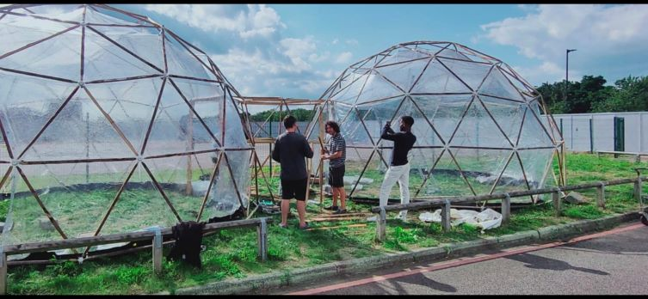

**Pollution Pods on the Green at the University of East London:** *The Pollution Pods is an immersive installation made up of five geodesic domes, emulating polluted environments in cities globally. Two of the Pods are currently being erected as part of the MArch ‘construction week’ and will be on display at Docklands from 27 September until 9 October.*

The Impact and Innovation Strategy is being presented to the Board of Governors in October and is reflective of the expected new Research Excellence Framework cycle which is likely to conclude around 2028. REF2021 results (performance between 2014-2020) will be published in May 2022.

With best wishes,

Amanda

**Professor Amanda J. Broderick**

BA (Hons) PhD DipM DipMRS PGCTL FRSA MBGS FCIMPFHEA

**Vice-Chancellor & President**